Terraform Task-3

1. Execute the script shown in the video.

1. First understand what a variable is
Suppose Terraform code has:
resource "local_file" "pet" {
filename = "pets.txt"
content = "We love pets"
}

Here pets.txt is hard-coded.
If tomorrow you want: /tmp/pets.txt
you have to modify main.tf. Instead, we create a variable:
variable "filename" {
default = "pets.txt"
}
Then:
resource "local_file" "pet" {
filename = var.filename
content = "We love pets"
}
Now the value can be changed without modifying the resource.
Basic syntax
variable "filename" {
default = "pets.txt"
type = string
description = "Path of the file to create"
}
And use it as: var.filename

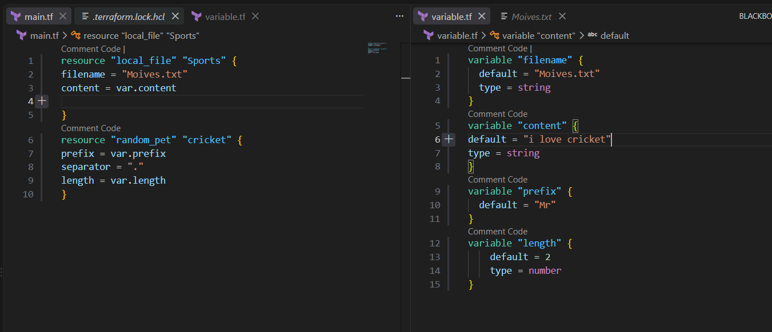

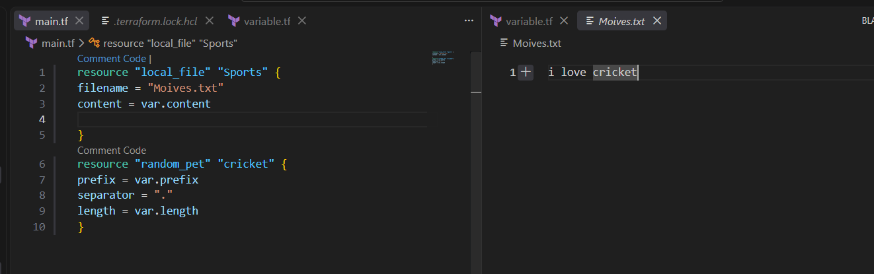

Changing content

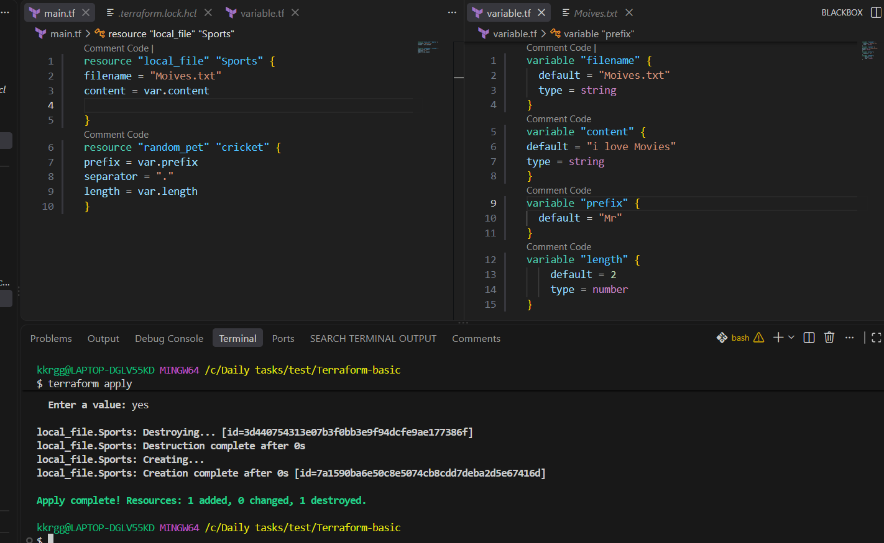
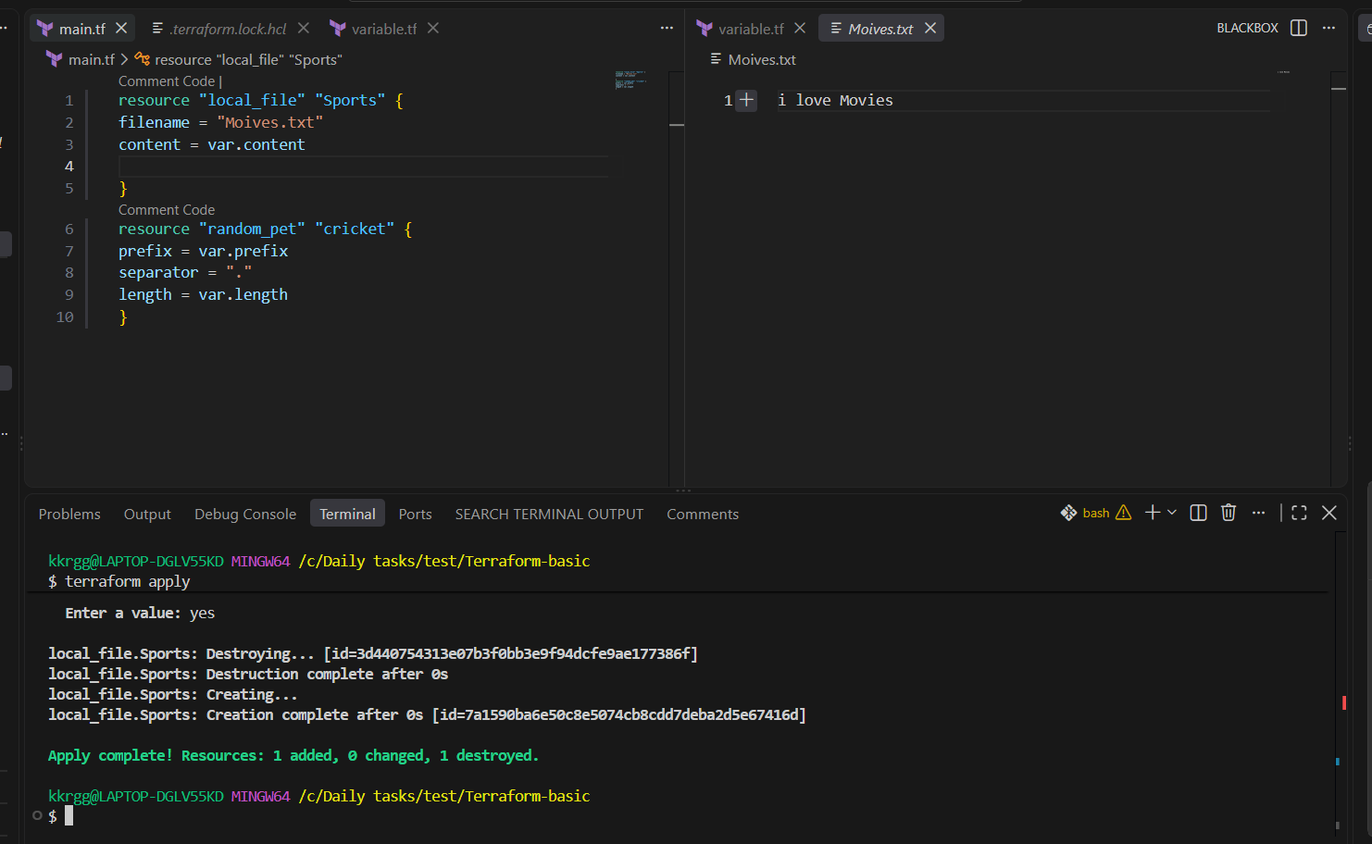

Command line flags

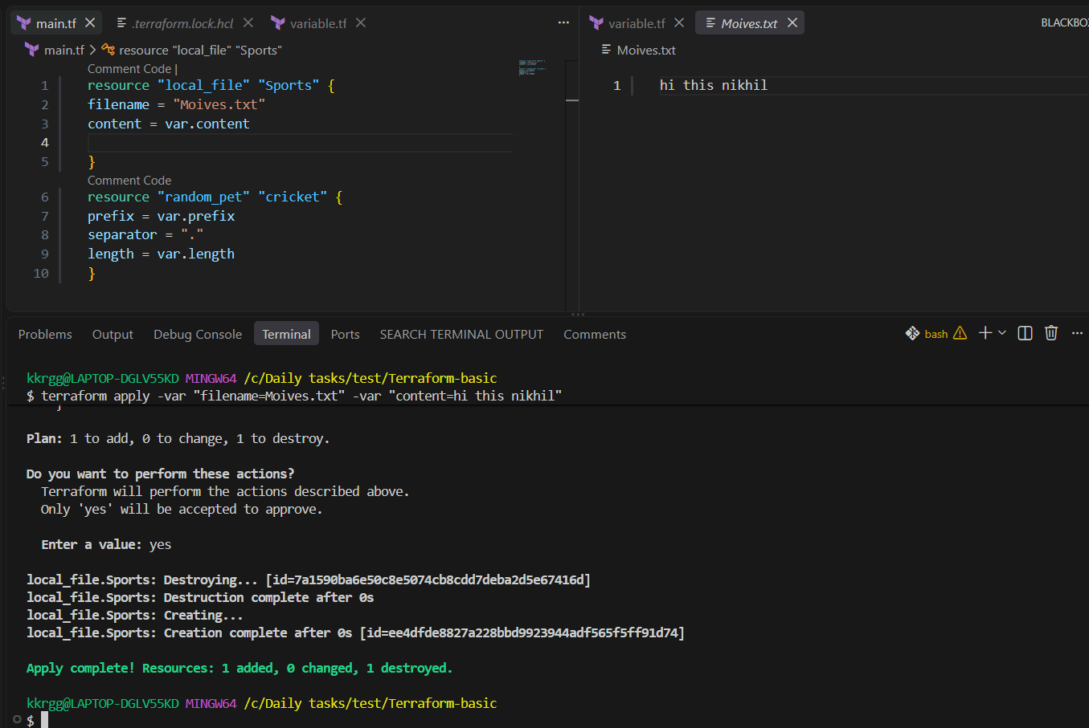

Using environmental variables
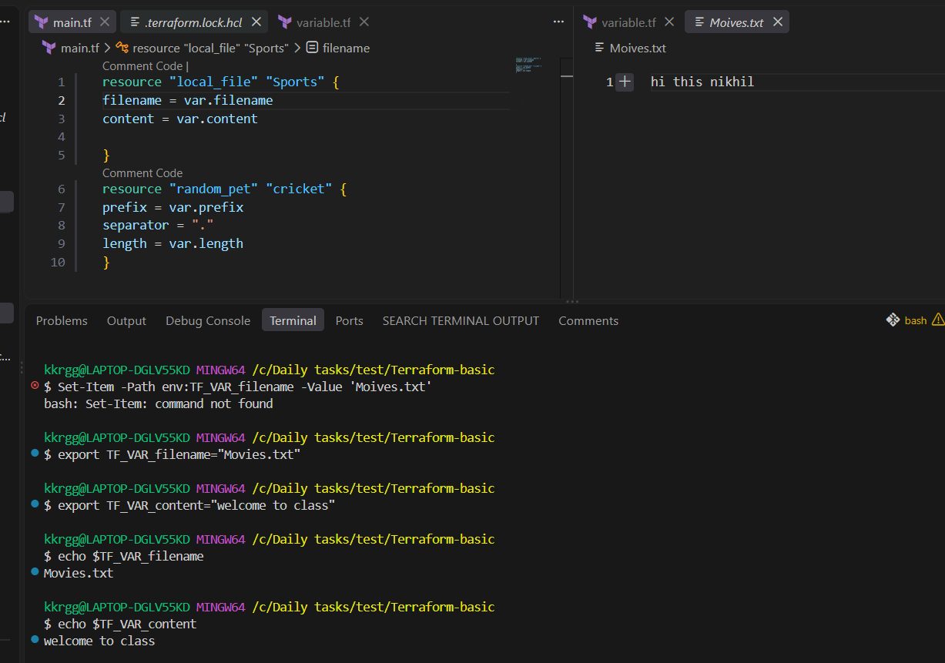

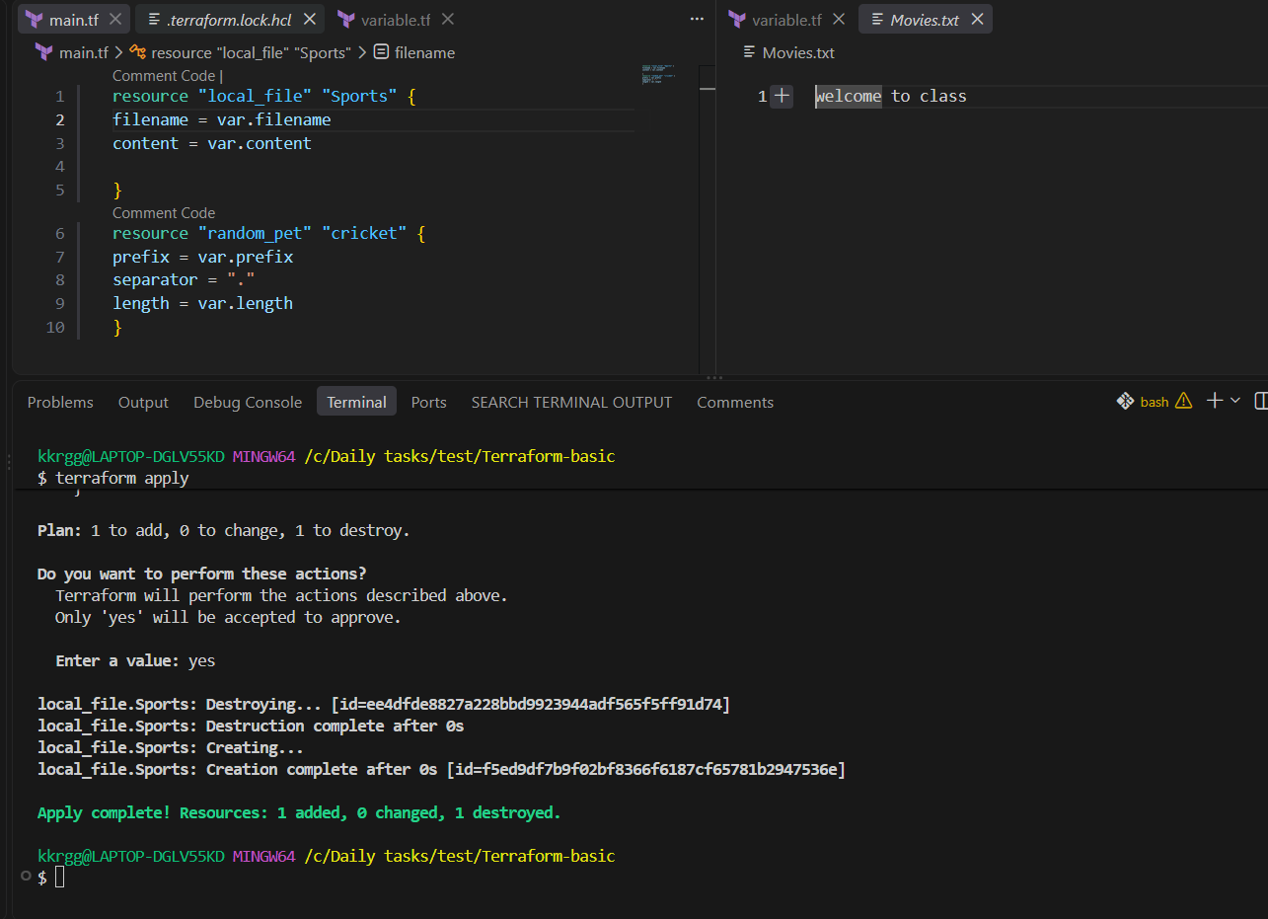

Using random name
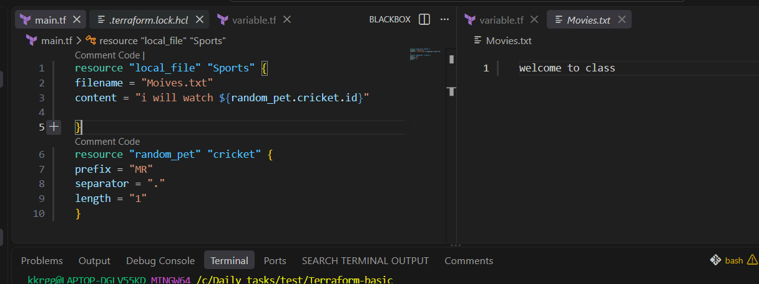

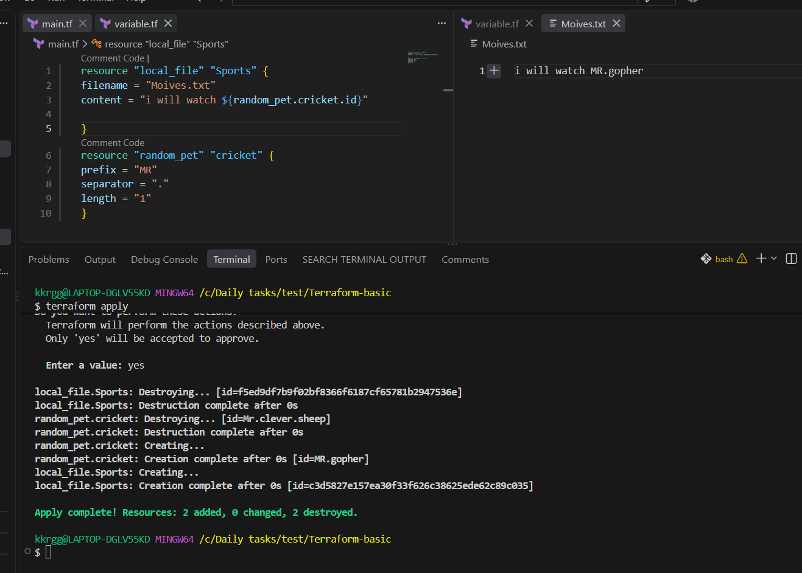

Output variables: these are used to display the output of the resource.
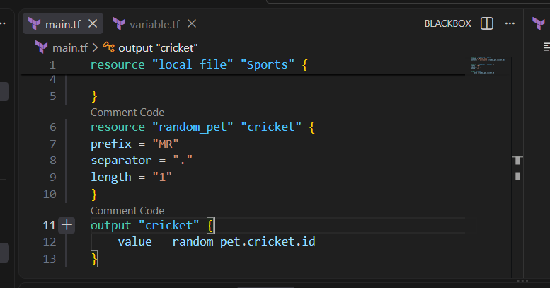

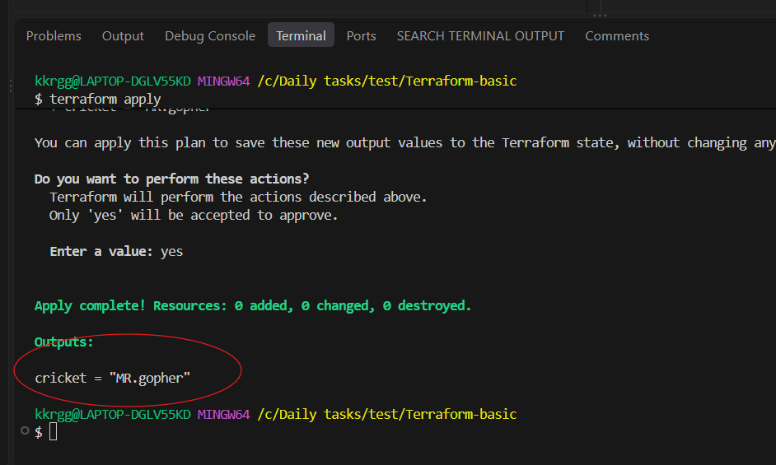

2. Integrate Terraform in Jenkins using the Terraform plugin.

Objective
The objective is to configure Jenkins so that Jenkins can execute Terraform commands automatically:
GitHub
↓
Jenkins
↓
Terraform Plugin
↓
terraform init
↓
terraform validate
↓
terraform plan
↓
terraform apply
↓
AWS Infrastructure
Since we already have Terraform installed on your Jenkins/EC2 environment, we'll focus on the Jenkins Terraform plugin integration.

Step 1 — Prepare Terraform project
Create a project directory:
mkdir terraform-jenkins
cd terraform-jenkins
Create:
terraform-jenkins/
├── main.tf
└── variables.tf
For a simple test, you can use a Terraform resource such as local_file.

main.tf
terraform {
required_providers {
local = {
source = "hashicorp/local"
version = "~> 2.5"
}
}

required_version = ">= 1.0"
}

provider "local" {}

resource "local_file" "example" {
filename = "${path.module}/jenkins-demo.txt"
content = "Terraform executed successfully from Jenkins!"
}
This is a good first test because it doesn't require AWS permissions.

Step 2 — Test Terraform manually first
This is important.
Go inside the Terraform project directory:
cd terraform-jenkins
Run:
terraform init
Then:
terraform validate
Then:
terraform plan
Finally:
terraform apply -auto-approve
You should see something like:
Apply complete! Resources: 1 added, 0 changed, 0 destroyed.
Check:
ls
You should have:
main.tf
jenkins-demo.txt
This confirms your Terraform code itself works before introducing Jenkins.

Step 3 — Push the Terraform project to GitHub
Inside your project:
git init
git add .
git commit -m "Add Terraform Jenkins integration"
Add your GitHub repository:
git remote add origin <YOUR_GITHUB_REPOSITORY>
Then:
git branch -M main
git push -u origin main
Your repository should contain:
terraform-jenkins/
│
├── main.tf
└── variables.tf

Step 4 — Install Terraform Plugin in Jenkins
Open Jenkins:
Jenkins
↓
Manage Jenkins
↓
Plugins
↓
Available plugins
Search:
Terraform
Install the Terraform plugin.
If Jenkins asks for a restart, restart Jenkins after installation.
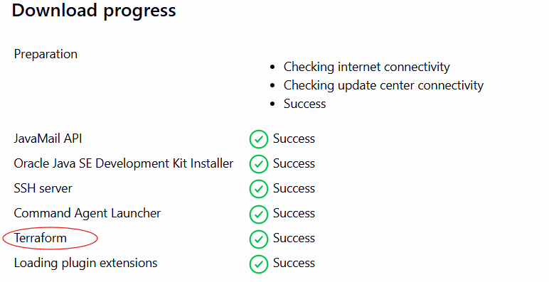

Step 5 — Configure Terraform in Jenkins
Go to:
Manage Jenkins
↓
Tools
Look for:
Terraform installations
Click:
Add Terraform
Give it a name:
Terraform
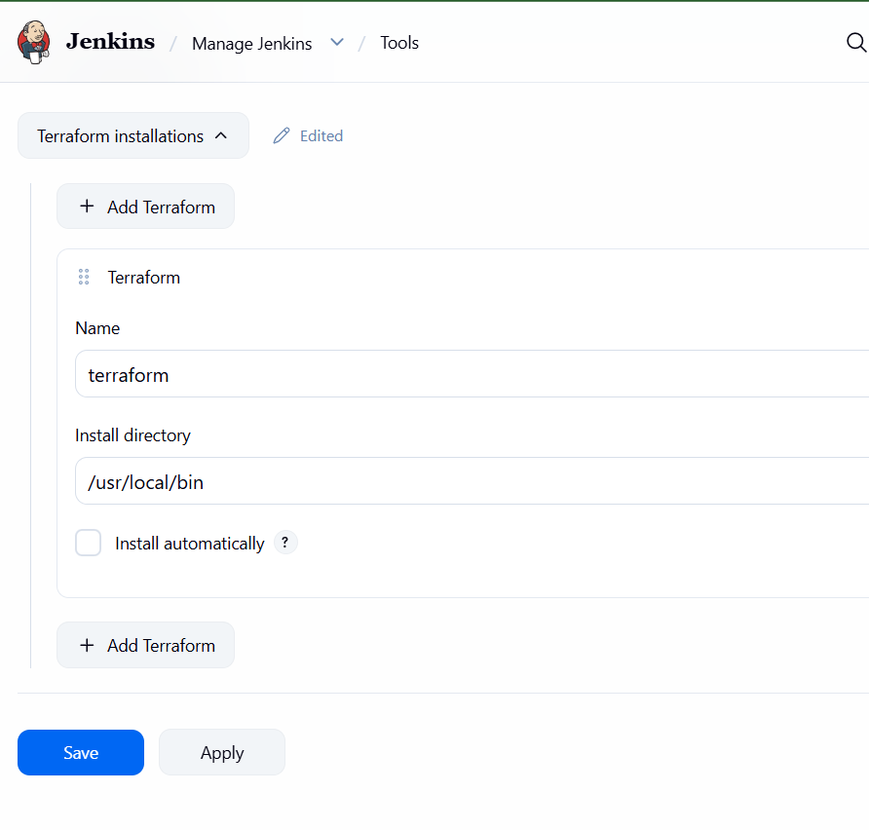

Step 6 — Create Jenkins Pipeline
Go to:
Jenkins
↓
New Item
Enter:
terraform-jenkins
Select:
Pipeline
Click OK.
Scroll to:
Pipeline
Choose:
Pipeline script
Use:
pipeline {
agent any

tools {
terraform 'terraform'
}

stages {

stage('Checkout') {
steps {
git branch: 'main',
url: 'https://github.com/YOUR_USERNAME/YOUR_REPOSITORY.git'
}
}

stage('Terraform Init') {
steps {
sh 'terraform init'
}
}

stage('Terraform Validate') {
steps {
sh 'terraform validate'
}
}

stage('Terraform Plan') {
steps {
sh 'terraform plan'
}
}

stage('Terraform Apply') {
steps {
sh 'terraform apply -auto-approve'
}
}
}
}
Replace:
YOUR_USERNAME
YOUR_REPOSITORY
with your actual GitHub repository.
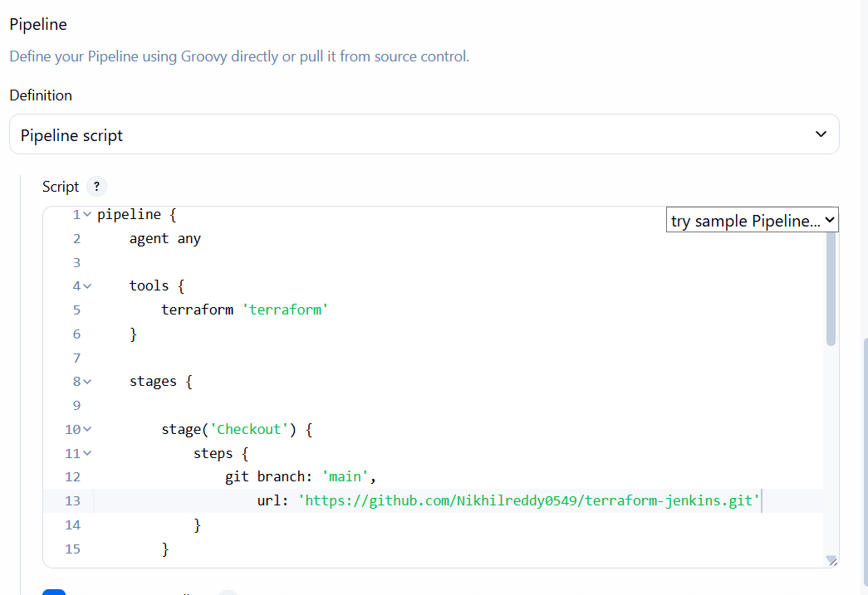

Step 7 — Build the Jenkins job
Click:
Build Now
Jenkins will execute:
Stage 1
Checkout
↓
GitHub repository

Stage 2
Terraform Init
↓
terraform init

Stage 3
Terraform Validate
↓
terraform validate

Stage 4
Terraform Plan
↓
terraform plan

Stage 5
Terraform Apply
↓
terraform apply -auto-approve

Step 8 — Check Console Output
Click the build:
Build #1
↓
Console Output
You should see:
Terraform has been successfully initialized!
Then:
Success! The configuration is valid.
Then the plan:
Plan: 1 to add, 0 to change, 0 to destroy.
Finally:
Apply complete! Resources: 1 added, 0 changed, 0 destroyed.
Your Jenkins build should finish:
Finished: SUCCESS
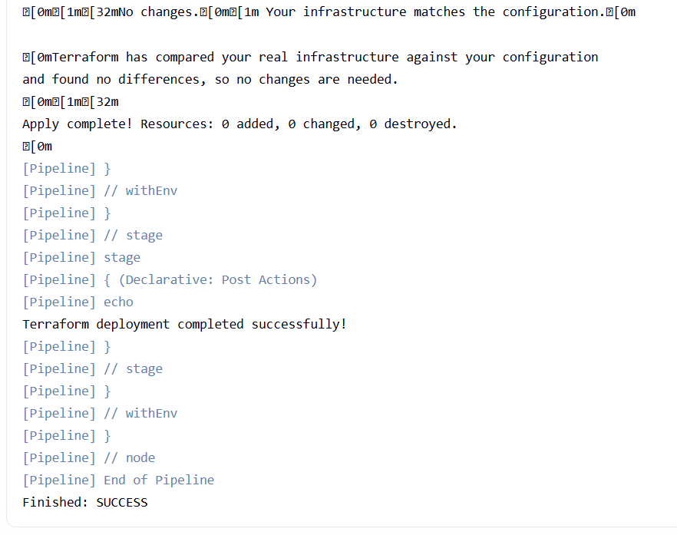
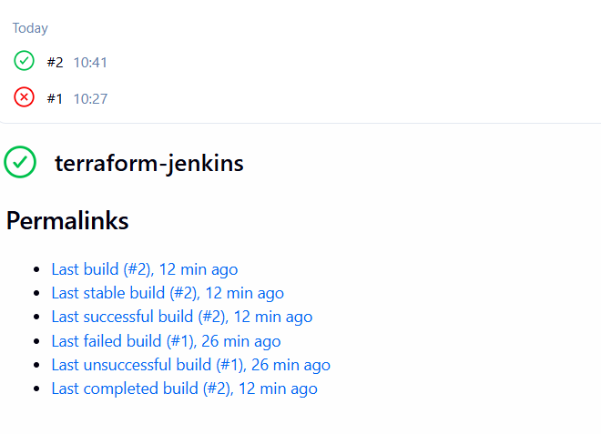

3. Create one Jenkins job using Maven Project for the code below with two stages:
  - Stage 1:Git clone
  - Stage 2:Maven Compilation Code: https://github.com/betawins/java-Working-app.git

Objective
To create a Jenkins Maven Project that automatically:
- Clones the Java application source code from GitHub.
- Compiles the application using Maven.
- Verifies that the application source code can be successfully compiled.
GitHub Repository:
https://github.com/betawins/java-Working-app.git

Job Details
Job Name:
java-working-maven
Project Type:
Maven project

Install Maven Integration Plugin
Go to:
Manage Jenkins → Plugins → Available plugins
Search for:
Maven Integration
Install it.
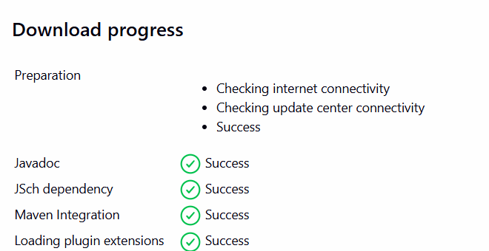

Workflow
GitHub Repository
↓
Stage 1: Git Clone
↓
Stage 2: Maven Compilation
↓
BUILD SUCCESS

Step 1: Create Jenkins Job
Go to:
Jenkins Dashboard → New Item
Enter:
java-working-maven
Select:
Maven project
Click OK.
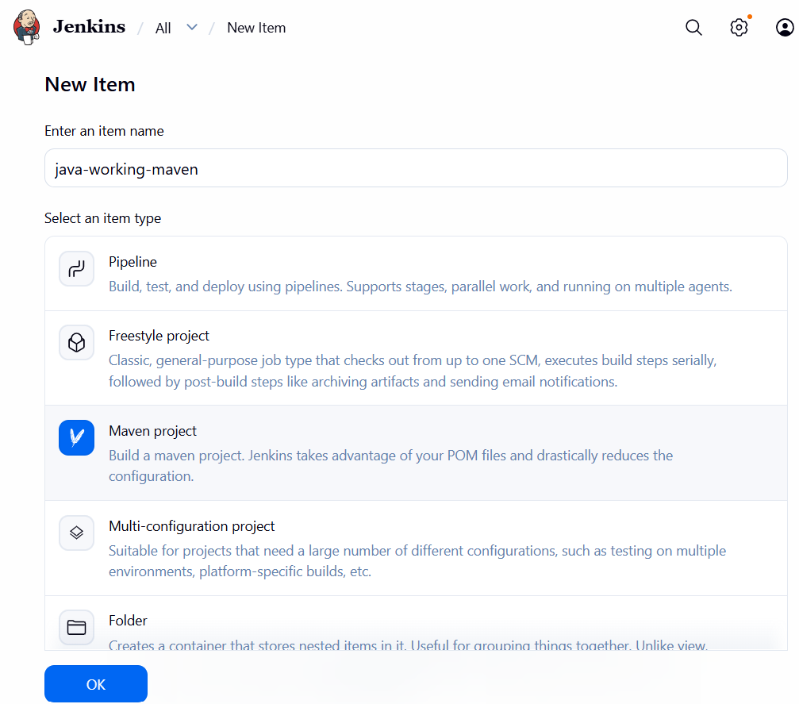

Step 2: Configure Git Clone
Go to:
Source Code Management
Select:
Git
Enter Repository URL:
https://github.com/betawins/java-Working-app.git
Branch Specifier:
*/main
If the repository uses another default branch, use that branch instead.
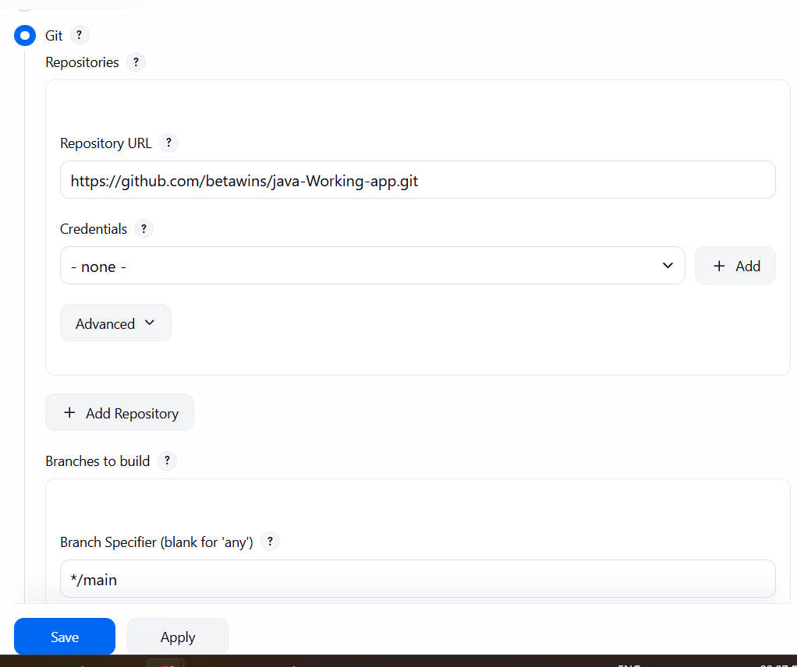

This represents Stage 1
Stage 1 → Git Clone
Jenkins will download the source code into the Jenkins workspace.

Step 3: Configure Maven Compilation
Scroll down to:
Build
Configure:

Root POM
pom.xml

Goals and options
clean compile
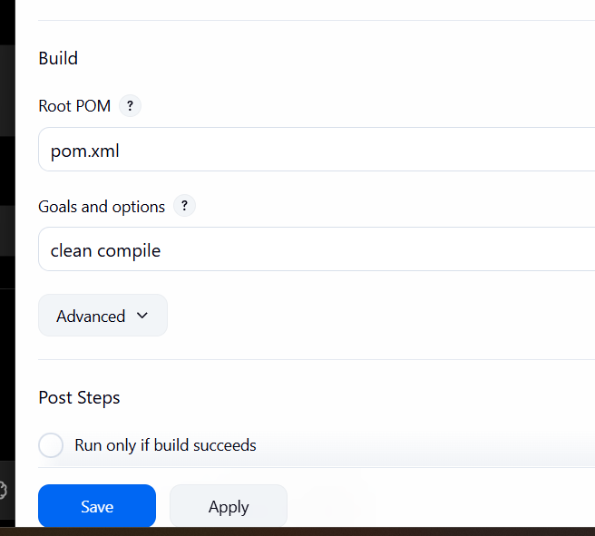
Jenkins will execute:
mvn clean compile

This represents Stage 2
Stage 2 → Maven Compilation

Step 4: Save and Build
Click:
Save → Build Now
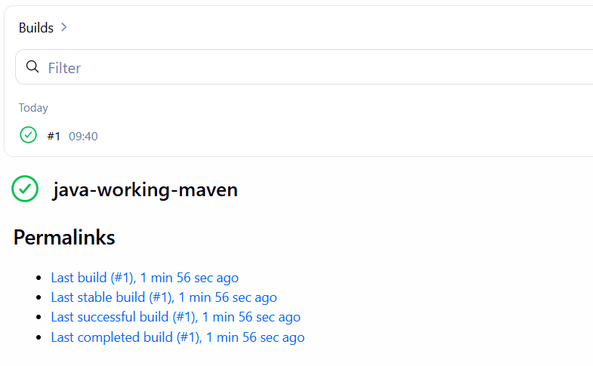
Open:
Build → Console Output
You should see Git checkout followed by Maven execution.
The important result should be:
[INFO] BUILD SUCCESS

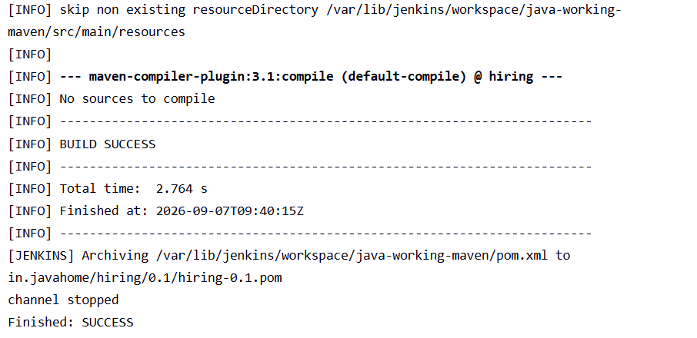

Expected Result
Git Clone
↓
Source Code Downloaded
↓
pom.xml detected
↓
mvn clean compile
↓
Java source compiled
↓
BUILD SUCCESS

Outcome
Successfully created a Jenkins Maven Project that clones the Java application from GitHub and compiles the application using Maven. The build completes successfully when the source code and dependencies are valid.

4. Use the same code and create a parameterized job in Jenkins with:
  - Stage 1:Git clone
  - Stage 2:Maven Compilation Code: https://github.com/betawins/java-Working-app.git

Objective
To create a parameterized Jenkins Maven Project using the same Java application, where the user can provide a Git branch dynamically before starting the build.
The job will:
- Accept a branch name as a parameter.
- Clone the selected branch from GitHub.
- Compile the application using Maven.
GitHub Repository:
https://github.com/betawins/java-Working-app.git

Job Details
Job Name:
java-working-parameterized
Project Type:
Maven project

Workflow
User selects/provides branch
↓
Stage 1: Git Clone
↓
Selected branch checked out
↓
Stage 2: Maven Compilation
↓
BUILD SUCCESS

Step 1: Create Jenkins Job
Go to:
Jenkins Dashboard → New Item
Enter:
java-working-parameterized
Select:
Maven project
Click OK.
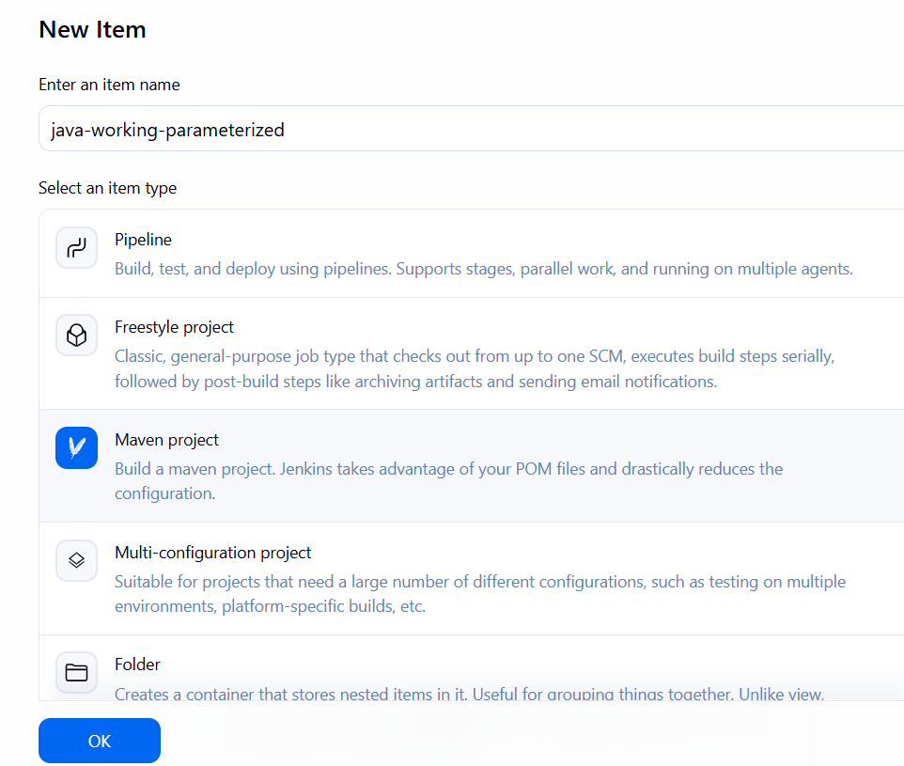

Step 2: Enable Parameterization
Under General, select:
☑ This project is parameterized
Click:
Add Parameter → String Parameter
Configure:
Setting | Value
Name | BRANCH
Default Value | main
Description | Enter the Git branch to build
So the parameter looks like:
BRANCH = main
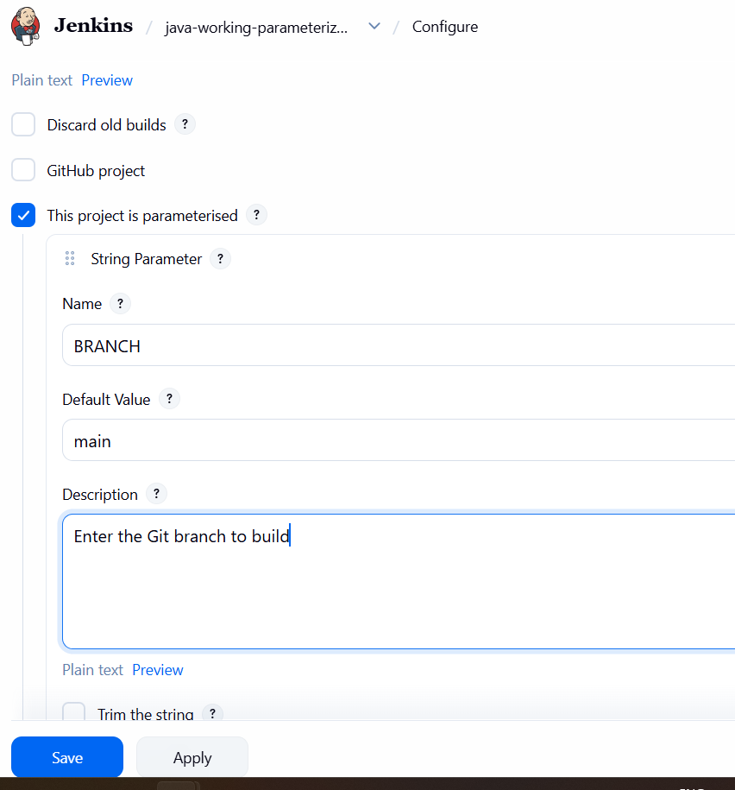

Step 3: Configure Git
Go to:
Source Code Management → Git
Repository URL:
https://github.com/betawins/java-Working-app.git
For Branch Specifier, enter:
*/${BRANCH}
This is important.
Instead of hardcoding:
*/main
we are telling Jenkins to use the value supplied through the BRANCH parameter.
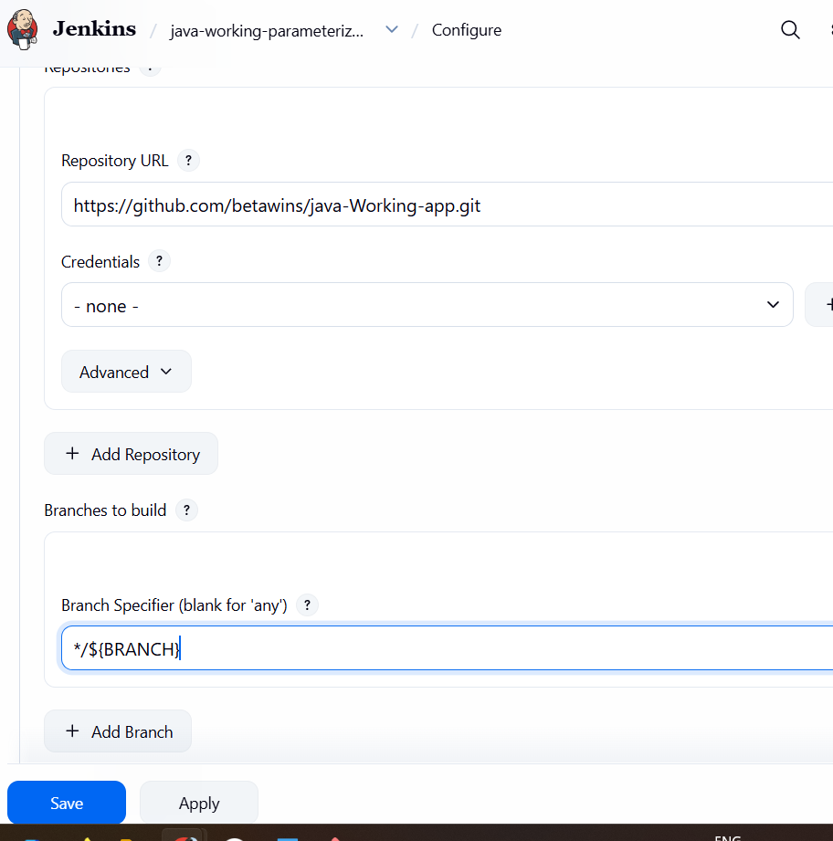
For example:
BRANCH = main
Jenkins checks out:
main
If you enter:
BRANCH = develop
Jenkins attempts to check out:
develop

Step 4: Configure Maven
Go to:
Build

Root POM
pom.xml

Goals and options
clean compile
Jenkins executes:
mvn clean compile
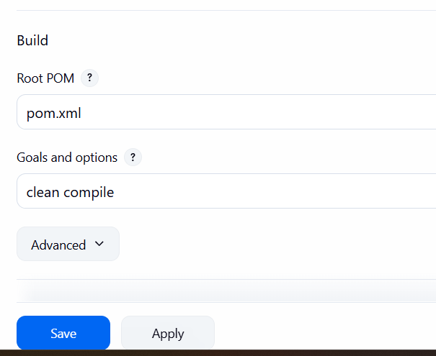

Step 5: Run Parameterized Build
Click:
Build with Parameters
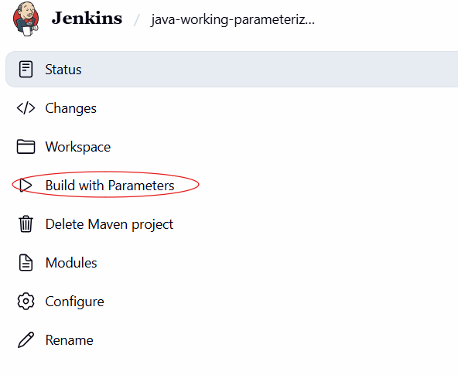
You should see:
BRANCH: [main]
Enter:
main
Click:
Build
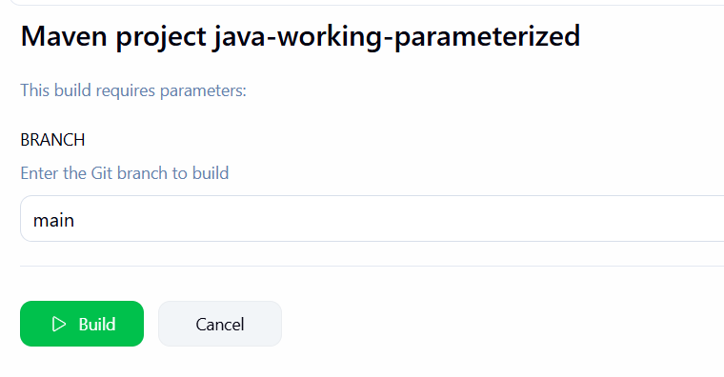
Jenkins will perform:
BRANCH = main
↓
Git Clone
↓
Checkout main branch
↓
Maven Compilation
↓
mvn clean compile
↓
BUILD SUCCESS

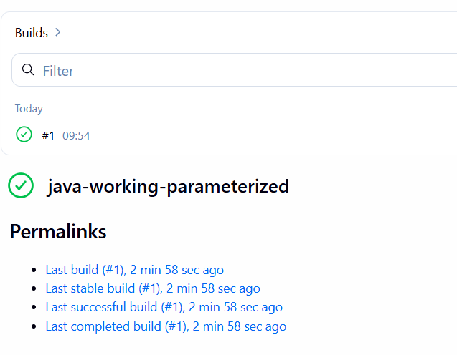

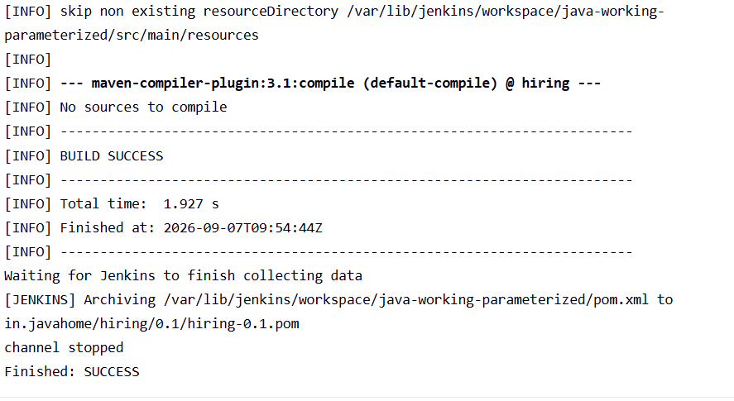

Outcome
The Jenkins job accepts the branch name from the user, clones the selected branch from GitHub, and performs Maven compilation successfully.

5. What are the global variables in Jenkins?

Objective
To understand the global variables available in Jenkins and how they can be used in Jenkins jobs and Pipeline scripts to access information such as the job name, build number, workspace, and Jenkins URL.

What are Global Variables in Jenkins?
Global variables are predefined variables provided by Jenkins that can be used across Jenkins jobs and Pipeline scripts.
They give us information about the current job, build, workspace, user, Git repository, and Jenkins environment.
For example:
BUILD_NUMBER
JOB_NAME
WORKSPACE
BUILD_URL
JENKINS_URL
Instead of manually entering these values, Jenkins automatically provides them.

Example
Suppose our Jenkins job is:
java-working-maven
and you run it for the 10th time.
Jenkins might provide:
BUILD_NUMBER = 10

JOB_NAME = java-working-maven

WORKSPACE = /var/lib/jenkins/workspace/java-working-maven

GIT_BRANCH = main

NODE_NAME = built-in
You can use these values inside scripts.

Outcome
These predefined variables allow us to dynamically access information about the Jenkins job, build, workspace, Git repository, node, and Jenkins server without hardcoding values.

Display Jenkins Global Variables

Objective
To create a Jenkins job that displays commonly used Jenkins global variables such as job name, build number, workspace, Git branch, and build URL.

Task
Create a Freestyle project named:
global-variable-demo
Configure it to print the following information:
Job Name
Build Number
Workspace
Build URL
Jenkins URL
Node Name

Step 1: Create Job
Go to:
Jenkins → New Item
Enter:
global-variable-demo
Select:
Freestyle project
Click OK.

Step 2: Add Build Step
Go to:
Build → Add build step → Execute shell
Enter:
echo "===== Jenkins Global Variables ====="

echo "Job Name : $JOB_NAME"
echo "Build Number : $BUILD_NUMBER"
echo "Workspace : $WORKSPACE"
echo "Build URL : $BUILD_URL"
echo "Jenkins URL : $JENKINS_URL"
echo "Node Name : $NODE_NAME"

echo "====================================="

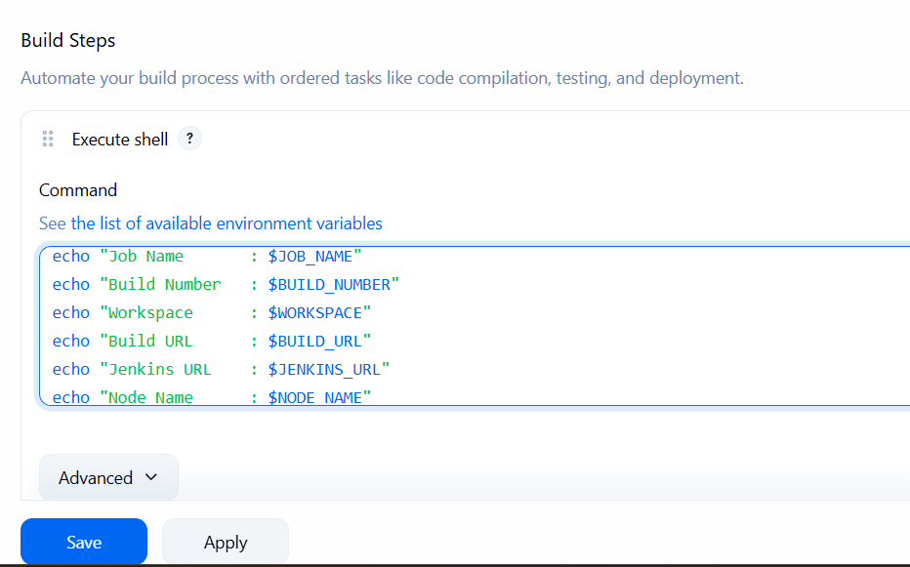

Step 3: Save and Build
Click:
Save → Build Now
Then open:
Build #1 → Console Output
You should see something similar to:
===== Jenkins Global Variables =====

Job Name : global-variable-demo
Build Number : 1
Workspace : /var/lib/jenkins/workspace/global-variable-demo
Build URL : http://<jenkins-server>/job/global-variable-demo/1/
Jenkins URL : http://<jenkins-server>/
Node Name : built-in

=====================================

Finished: SUCCESS
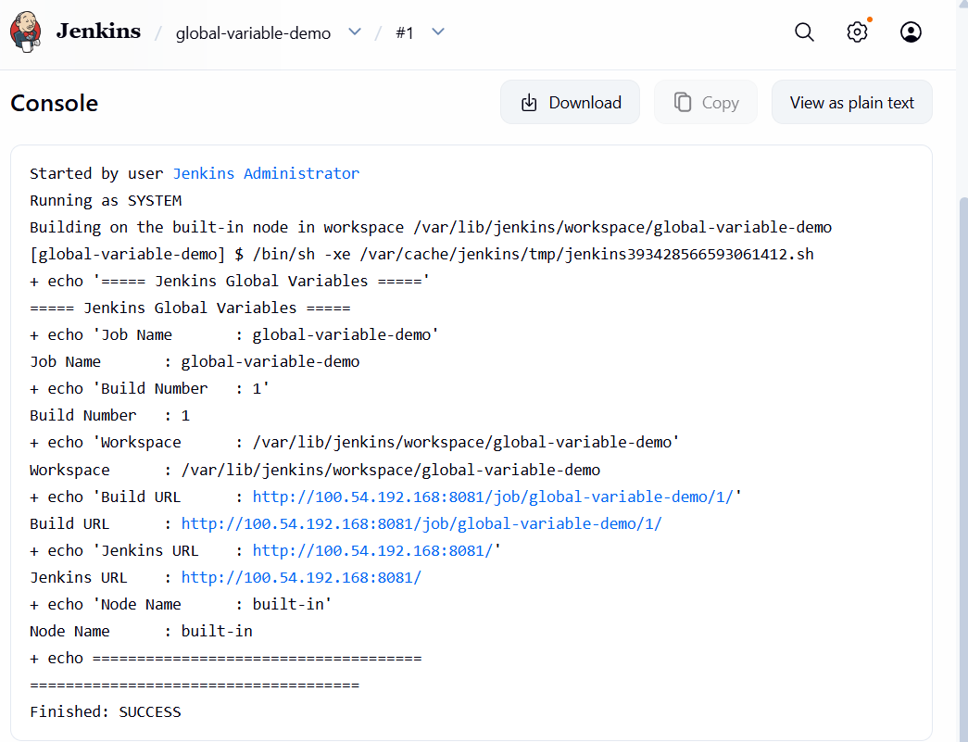

Step 4: Run the Job Again
Click Build Now again.
Now notice:
Build Number : 2

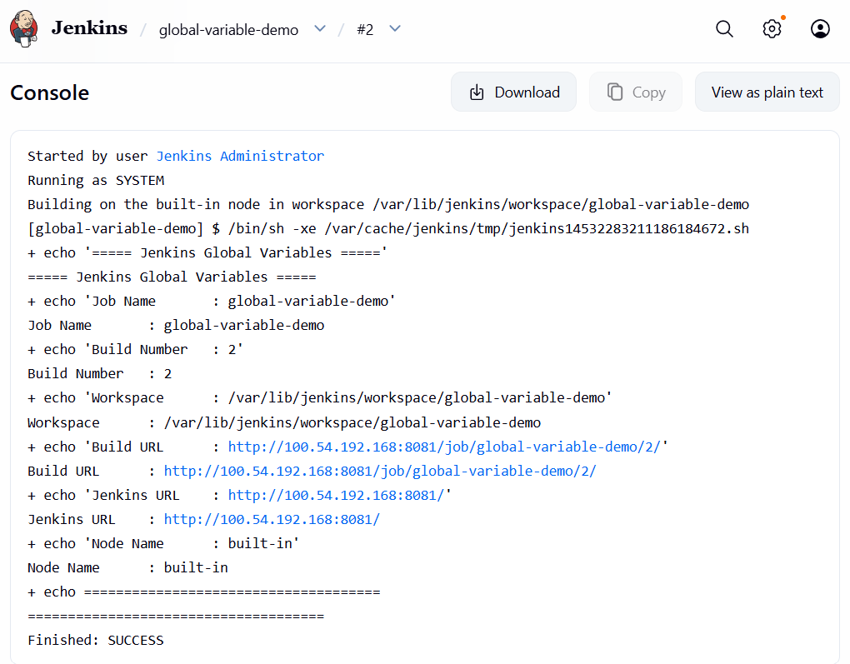
Run it one more time:
Build Number : 3

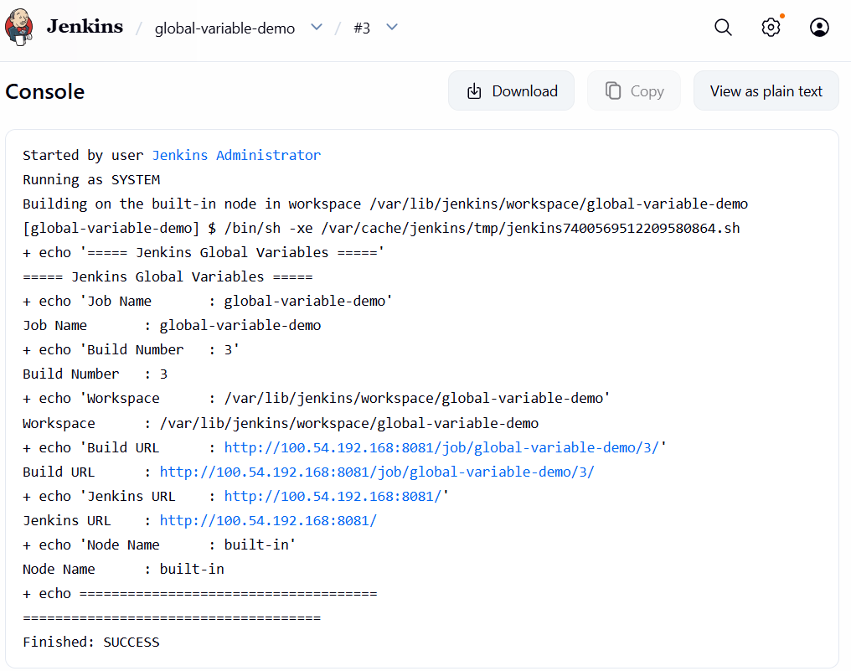
So you can directly observe that:
BUILD_NUMBER
↓
1 → 2 → 3 → 4 → ...
Jenkins automatically changes this variable for every build.
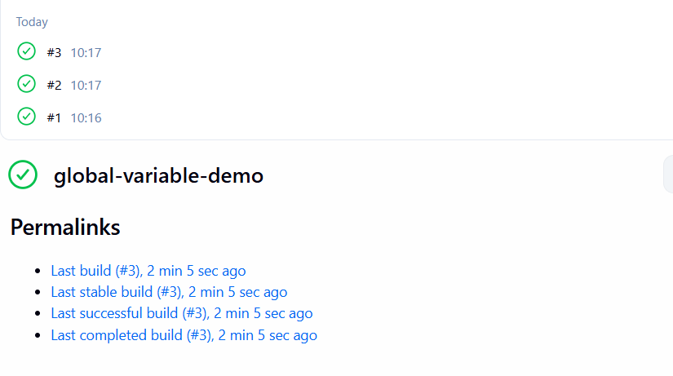

Outcome
Successfully created a Jenkins job that displays commonly used global variables. By running the job multiple times, I verified that Jenkins automatically provides dynamic information such as the job name, build number, workspace location, and build URL.

